Net 1060 Introduction to Networks Lab: # 17.8.2

Name:

Follow the instructions down below for the lab itself. For this lab, all answers need to be in blue font. For the questions right below, answer in complete sentences. Ensure you paste the screen shot of your score page at the bottom of the document. Even if this does not let you see your grade, still take a screen shot of the score page showing congratulations “your name” you have completed the exercise is pasted at the bottom of this document. You will then need to upload both this word document and your packet tracer file to the assignments link within Netacad. Let the instructor know if you have any questions.

Lab Analysis Report

1. Using complete sentences summarize work you completed during the lab.
In this lab I configured all the switches, routers, and pc’s on the network. I subnetted the network and assigned all the ips to the devices. Then I did all the security configurations on the router and switches. Then I tested connectivity between the devices.

2. Using complete sentences describe what you learned from the lab. Hint; look at the lab objectives listed at the top of the lab section.
In this lab I learned how to put all the skills I’ve learned together. I learned how to use subnetting and build a network off of it.

Problems Encountered

1. Using complete sentences describe any problem(s) experienced during lab.
I didn’t experience any problems.

2. Using complete sentences describe how you solved your problem(s).

3. Using complete sentences explain if you needed any assistance with the lab; then list what you learned from that assistance.

Packet Tracer – Skills Integration Challenge

Addressing Table
Device | Interface | IP Address / Prefix | Default Gateway
R1 | G0/0 | 192.168.0.1/25 | N/A
R1 | G0/0 | 2001:db8:acad::1/64 | N/A
R1 | G0/0 | fe80::1 | N/A
R1 | G0/1 | 192.168.0.129/26blank | N/A
R1 | G0/1 | 2001:db8:acad:1::1/64 | N/A
R1 | G0/1 | fe80::1 | N/A
R1 | G0/2 | 192.168.0.193/27blank | N/A
R1 | G0/2 | 2001:db8:acad:2::1/64 | N/A
R1 | G0/2 | fe80::1 | N/A
R1 | S0/0/1 | 172.16.1.2 /30 | N/A
R1 | S0/0/1 | 2001:db8:2::1/64 | N/A
R1 | S0/0/1 | fe80::1 | N/A
Central | S0/0/0 | 209.165.200.226 /30 | N/A
Central | S0/0/0 | 2001:db8:1::1/64 | N/A
Central | S0/0/0 | fe80::2 | N/A
Central | S0/0/1 | 172.16.1.1 /30 | N/A
Central | S0/0/1 | 2001:db8:2::2/64 | N/A
Central | S0/0/1 | fe80::2 | N/A
S1 | VLAN 1 | 192.168.0.2/25blank | 192.168.0.1blank
S2 | VLAN 1 | 192.168.0.130/26 | 192.168.0.129
S3 | VLAN 1 | 192.168.0.194/27 | 192.168.0.193blank
Staff | NIC | 192.168.0.126/25 | 192.168.0.1
Staff | NIC | 2001:db8:acad::2/64 | fe80::1
Staff | NIC | fe80::2 | fe80::1
Sales | NIC | 192.168.0.190/26blank | 192.168.0.129blank
Sales | NIC | 2001:db8:acad:1::2/64 | fe80::1
Sales | NIC | fe80::2 | fe80::1
IT | NIC | 192.168.0.222/27 | 192.168.0.193
IT | NIC | 2001:db8:acad:2::2/64 | fe80::1
IT | NIC | fe80::2 | fe80::1
Web | NIC | 64.100.0.3 /29 | 64.100.0.1
Web | NIC | 2001:db8:cafe::3/64 | fe80::1
Web | NIC | fe80::2 | Fe80::1

Background / Scenario
The router Central, ISP cluster, and the Web server are completely configured. You must create a new IPv4 addressing scheme that will accommodate 4 subnets using the 192.168.0.0/24 network. The IT department requires 25 hosts. The Sales department needs 50 hosts. The subnet for the rest of the staff requires 100 hosts. A Guest subnet will be added in the future to accommodate 25 hosts. You must also finish the basic security settings and interface configurations on R1. Then, you will configure the SVI interface and basic security settings on switches S1, S2, and S3.

Instructions
IPv4 Addressing
- Use 192.168.0.0/24 to create subnets that meet the host requirements.
- Staff: 100 hosts
- Sales: 50 hosts
- IT: 25 hosts
- Guest network to be added later: 25 hosts
- Document the IPv4 addresses that have been assigned in the Addressing Table.
The Staff subnet is 192.168.0.0/25. The Sales subnet is 192.168.0.128/26. The IT subnet is 192.168.0.192/27. The Guest subnet is 192.168.0.224/27.
- Record the subnet for the Guest network:
The Guest subnet is 192.168.0.224/27.Type your answers here.
PC Configurations
- Configure the assigned IPv4 address, subnet mask, and default gateway settings on the Staff, Sales, and IT PCs using your addressing scheme.
- Assign the IPv6 unicast and link local addresses and default gateways to the Staff, Sales, and IT networks according to the Addressing Table.
R1 Configurations
- Configure the device name according to the Addressing Table.
- Disable DNS lookup.
- Assign Ciscoenpa55 as the encrypted privileged EXEC mode password.
- Assign Ciscoconpa55 as the console password and enable login.
- Require that a minimum of 10 characters be used for all passwords.
- Encrypt all plaintext passwords.
- Create a banner that warns anyone accessing the device that unauthorized access is prohibited.
- Configure and enable all the Gigabit Ethernet interfaces.
- Configure the IPv4 addresses according to your addressing scheme.
- Configure the IPv6 addresses according to the Addressing Table.
- Configure SSH on R1:
- Set the domain name to CCNA-lab.com
- Generate a 1024-bit RSA key.
- Configure the VTY lines for SSH access.
- Use the local user profiles for authentication.
- Create a user Admin1 with a privilege level of 15 and use the encrypted password of Admin1pa55.
- Configure the console and VTY lines to log out after five minutes of inactivity.
- Block anyone for three minutes who fails to log in after four attempts within a two-minute period.
Switch Configuration
- Configure the device name according to the Addressing Table.
- Configure the SVI interface with the IPv4 address and subnet mask according your addressing scheme.
- Configure the default gateway.
- Disable DNS lookup.
- Assign Ciscoenpa55 as the encrypted privileged EXEC mode password.
- Assign Ciscoconpa55 as the console password and enable login.
- Configure the console and VTY lines to log out after five minutes of inactivity.
- Encrypt all plaintext passwords.
Connectivity Requirements
- Use the web browser on the Staff, Sales, and IT PCs to navigate to www.cisco.pka.
- Use the web browser on the Staff, Sales, and IT PCs to navigate to www.cisco6.pka.
- All PCs should be able to ping all other the devices.
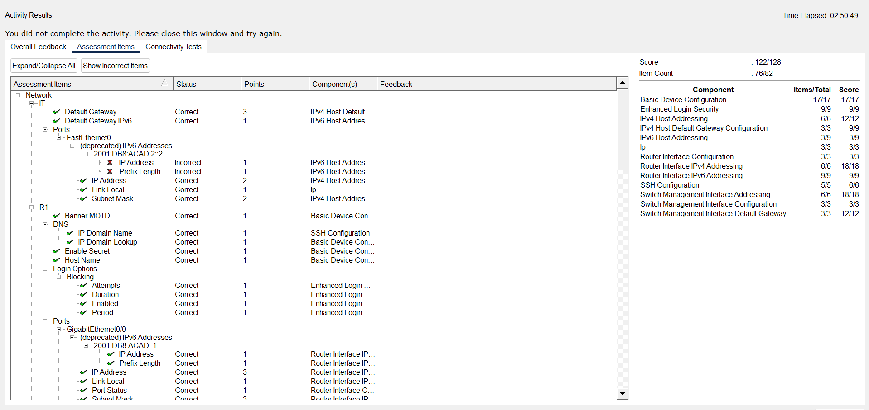
End of document

